The problem of AI deck unable to release WiFi signal
I bought AI deck and used it on crazyflie, but it didn't automatically send out a WiFi signal as expected. According to the description of the webpage ^{[1]}, I think I need to refresh the firmware of AI deck myself.
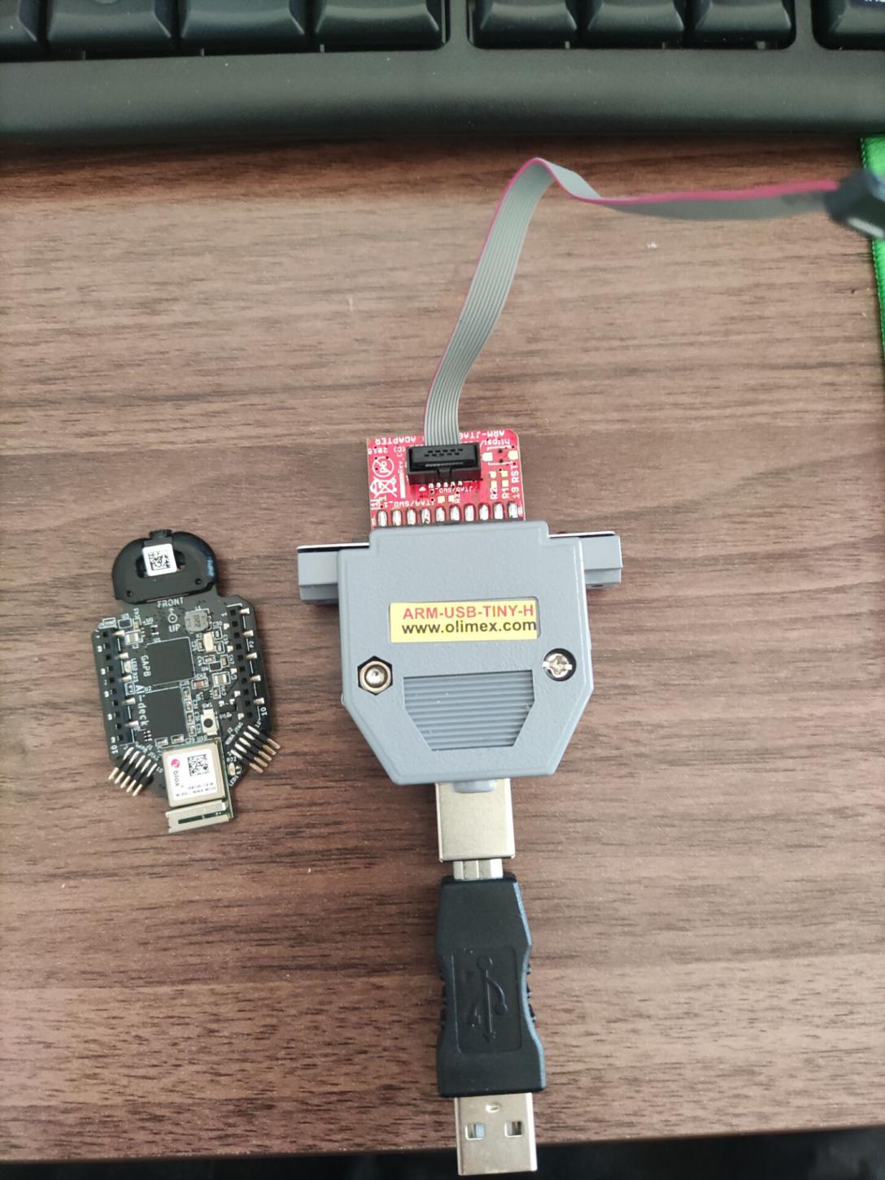
Obviously, I need to work on two modules, one is gap8, the other is Nina.
For gap8:
Referring to the web information ^{[2]}, I executed the following commands and ensured that there was no error in the process:
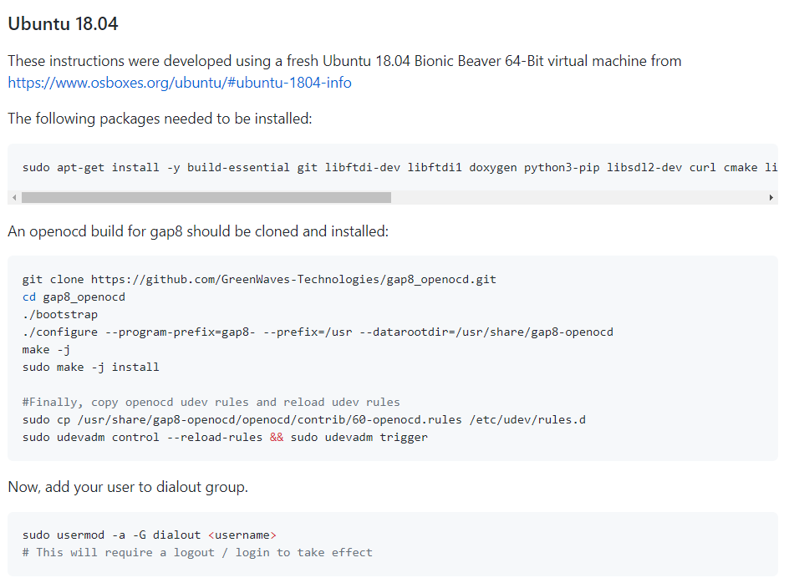
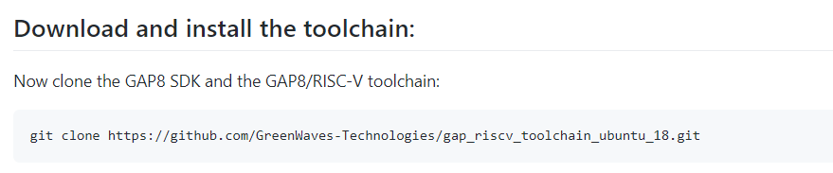
After installing the above environment, I download the gap_ sdk：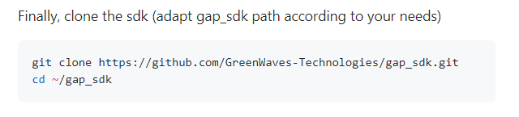

Then configure the SDK with the following command:
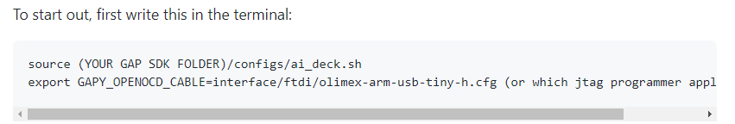

Then it's installation:
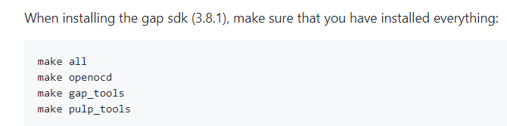

Under the directory gap_ sdk, I run the “make all” and it generate error：
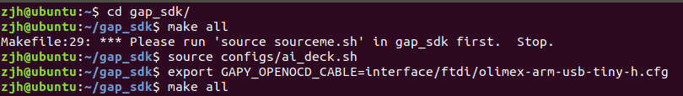
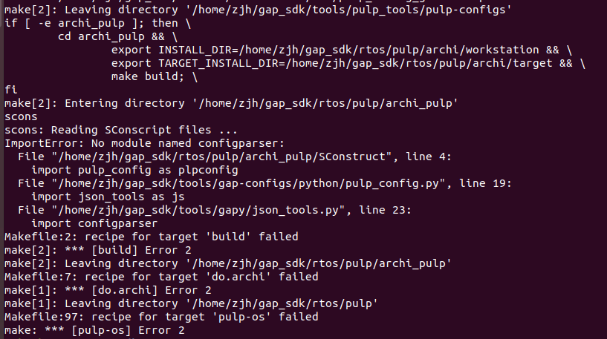
The content of the error report is that the configparser model cannot be found, but it has been used requirements.txt
The required pyhton library is installed, and you can check that:
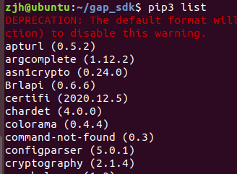
So the flash of gap8 can't go on.

About the flash of Nina:
According to the web page ^{[3]}, use docker to flash. After entering “menuconfig”, I don't know how to operate, and I find that AP (access point) has been selected in menu "Ai deck example configuration".
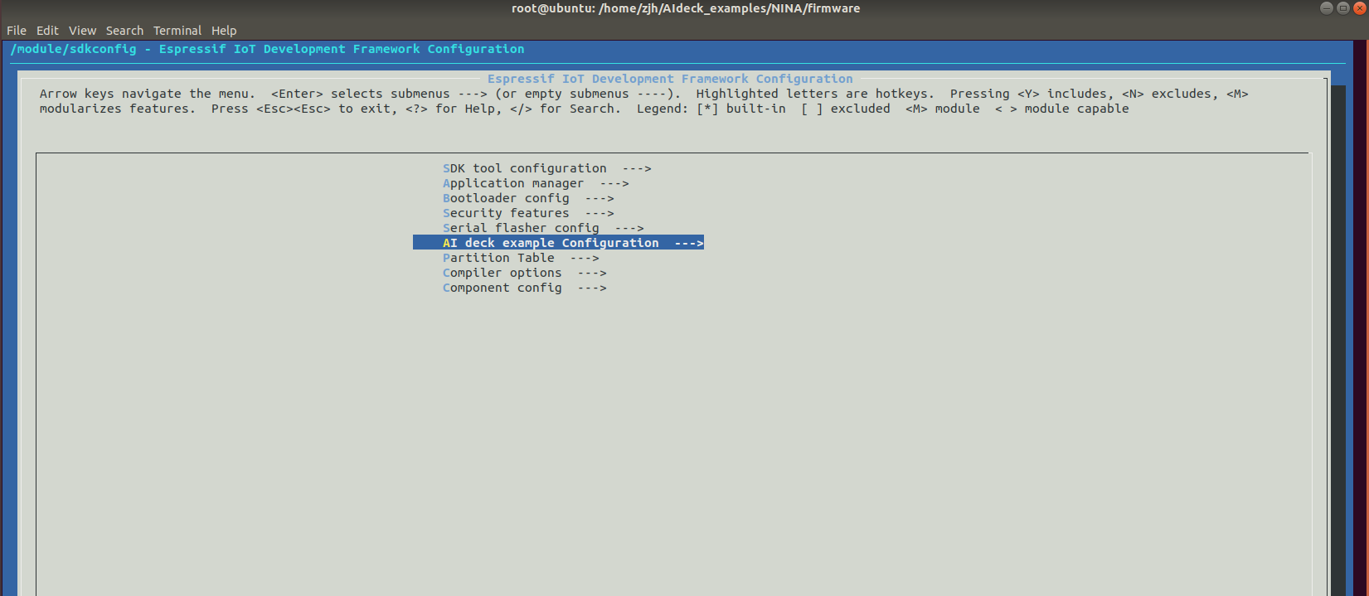
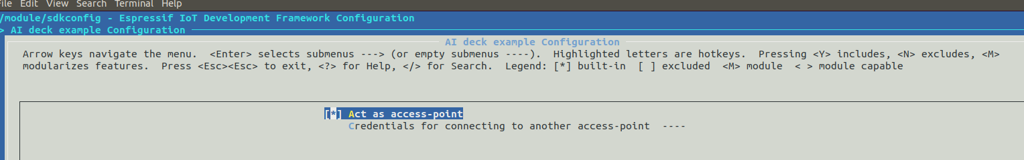
Besides, I don't know what the make in this place means:
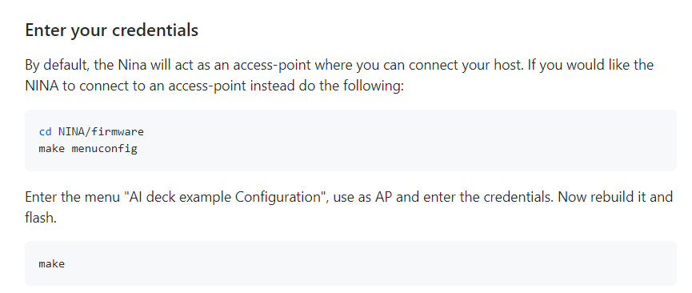
After selecting exit in the previous interface, an error is reported as follows:
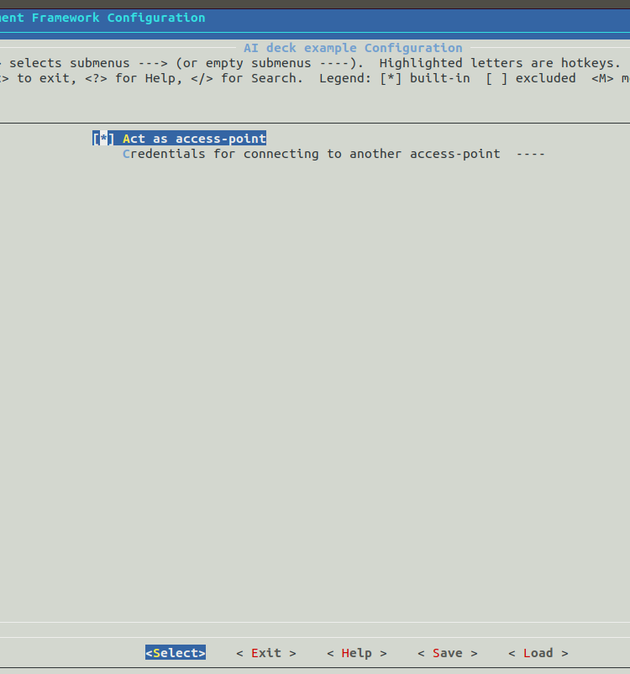

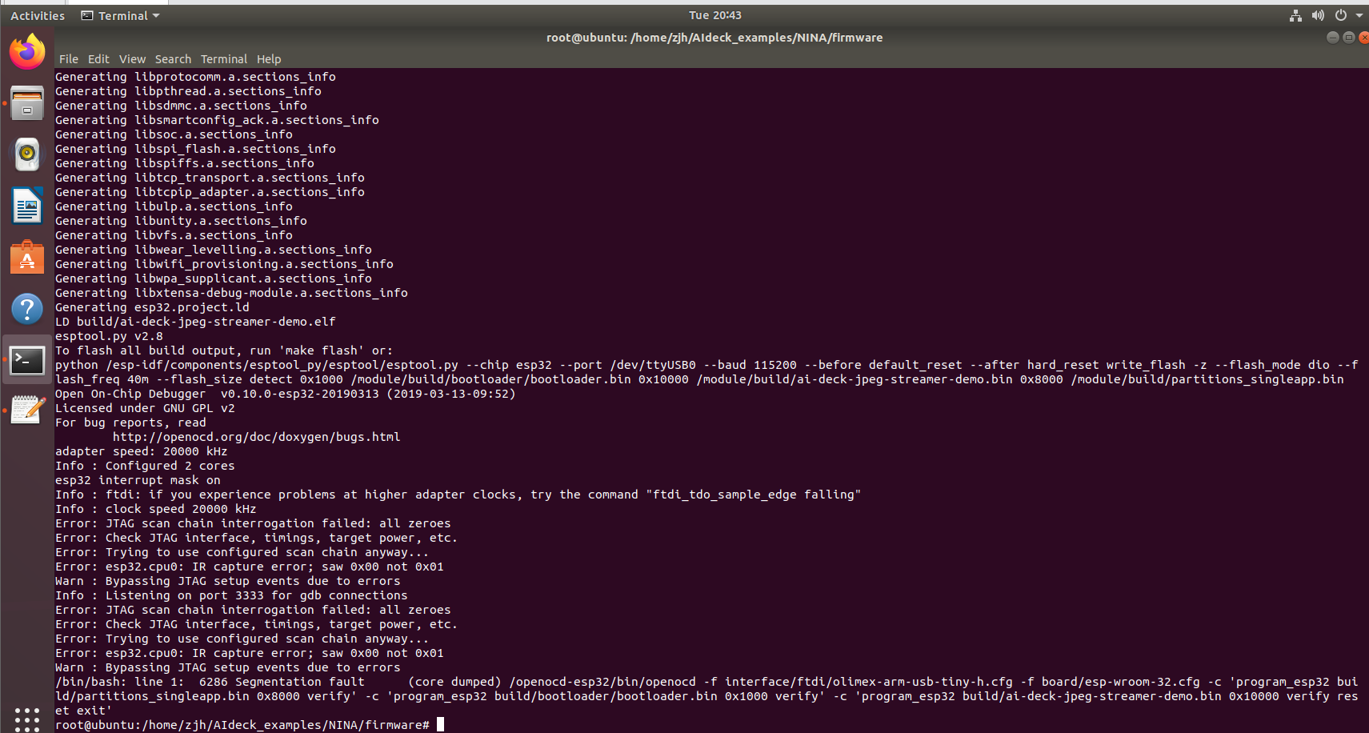
Does it mean that the problem happens on the JTAG?

Because AI deck can't release WiFi signal, the following steps can't go on. I've been in this card for a long time. I hope I can get your help! Thanks!

Sincerely
2021/1/13

- https://github.com/bitcraze/AIdeck_examples/blob/master/docs/getting-started/tryout.md
- https://github.com/GreenWaves-Technologies/gap_sdk.
- https://github.com/bitcraze/AIdeck_examples/blob/master/docs/nina-instructions/docker-nina.md

